

FOOTBALL

The Game

***MULTIMEDIA TOOLS AND DESIGN (15IT343E)***

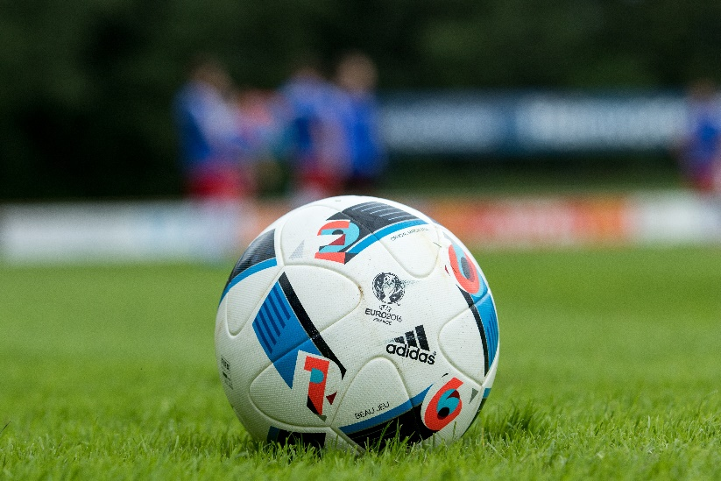

March 25, 2020

Ousnik Polley

RA1711003011018

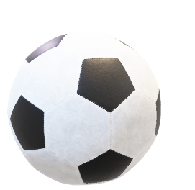

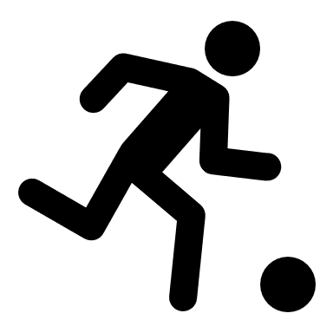**Association football**, more commonly known as **football** or **soccer**,[[a]](https://en.wikipedia.org/wiki/Association_football#cite_note-5) is a [team sport](https://en.wikipedia.org/wiki/Team_sport) played with a spherical [ball](https://en.wikipedia.org/wiki/Ball_(association_football)) between two teams of 11 [players](https://en.wikipedia.org/wiki/Football_player). It is played [1]by approximately 250 million players in over 200 countries and dependencies, making it the [world's most popular sport](https://en.wikipedia.org/wiki/List_of_professional_sports). The game is played on a rectangular field called a [pitch](https://en.wikipedia.org/wiki/Football_pitch) with a [goal](https://en.wikipedia.org/wiki/Goal_(sport)) at each end. The object of the game is to [score](https://en.wikipedia.org/wiki/Scoring_in_association_football) by moving the ball beyond the goal line into the opposing goal.

Football is played in accordance with a set of rules known as the [Laws of the Game](https://en.wikipedia.org/wiki/Laws_of_the_Game_(association_football)). The ball is 68–70 cm (27–28 in) in circumference and known as the [*football*](https://en.wikipedia.org/wiki/Ball_(association_football)).

Players are not allowed to touch the ball with hands or arms while it is in play, except for the [goalkeepers](https://en.wikipedia.org/wiki/Goalkeeper_(association_football)) within the [penalty area](https://en.wikipedia.org/wiki/Penalty_area).

Football is played in accordance with a set of rules known as the [Laws of the Game](https://en.wikipedia.org/wiki/Laws_of_the_Game_(association_football)). The ball is 68–70 cm (27–28 in) in circumference and known as the [*football*](https://en.wikipedia.org/wiki/Ball_(association_football)). The two teams each compete to get the ball into the other team's goal (between the posts and under the bar), thereby scoring a goal. The team that has scored more goals at the end of the game is the winner; if both teams have scored an equal number of goals then the game is a draw. Each team is led by a [captain](https://en.wikipedia.org/wiki/Captain_(association_football)) who has only one official responsibility as mandated by the Laws of the Game: to represent their team in the coin toss prior to kick-off or [penalty kicks](https://en.wikipedia.org/wiki/Penalty_kick_(association_football)).[[5]](https://en.wikipedia.org/wiki/Association_football#cite_note-laws51-52-6)

Players are not allowed to touch the ball with hands or arms while it is in play, except for the [goalkeepers](https://en.wikipedia.org/wiki/Goalkeeper_(association_football)) within the [penalty area](https://en.wikipedia.org/wiki/Penalty_area). Other players mainly use their feet to strike or pass the ball, but may also use any other part of their body except the hands and the arms. The team that scores most goals by the end of the match wins. If the score is level at the end of the game, either a [draw](https://en.wikipedia.org/wiki/Tie_(draw)) is declared or the game goes into [extra time](https://en.wikipedia.org/wiki/Extra_time) or a [penalty shootout](https://en.wikipedia.org/wiki/Penalty_shootout_(association_football)) depending on the format of the competition.

Football is governed internationally by the [International Federation of Association Football](https://en.wikipedia.org/wiki/FIFA) (FIFA), which organises [World Cups](https://en.wikipedia.org/wiki/FIFA_World_Cup) for both men and [women](https://en.wikipedia.org/wiki/FIFA_Women%27s_World_Cup) every four years.[[6]](https://en.wikipedia.org/wiki/Association_football#cite_note-7) The FIFA World Cup has taken place every four years since [1930](https://en.wikipedia.org/wiki/1930_FIFA_World_Cup) with the exception of 1942 and 1946 tournaments, which were cancelled due to [World War II](https://en.wikipedia.org/wiki/World_War_II). Approximately 190–200 national teams compete in qualifying tournaments within the scope of continental confederations for a place in the finals. The finals tournament, which is held every four years, involves 32 national teams competing over a four-week period.[[b]](https://en.wikipedia.org/wiki/Association_football#cite_note-8) It is the most prestigious football tournament in the world as well as the most widely viewed and followed sporting event in the world, exceeding the [Olympic Games](https://en.wikipedia.org/wiki/Olympic_Games).

**WORLD CHAMPIONS**

**UEFA CHAMPIONS**

The most prestigious competition in club football is the [UEFA Champions League](https://en.wikipedia.org/wiki/UEFA_Champions_League) which attracts an extensive television audience throughout the world. The final of the tournament has been, in recent years, the most-watched annual sporting event in the world.[[7]](https://en.wikipedia.org/wiki/Association_football#cite_note-9) The top five [European leagues](https://en.wikipedia.org/wiki/List_of_top-division_football_clubs_in_UEFA_countries) are the [Premier League](https://en.wikipedia.org/wiki/Premier_League) (England), [La Liga](https://en.wikipedia.org/wiki/La_Liga) (Spain), [Bundesliga](https://en.wikipedia.org/wiki/Bundesliga) (Germany), [Serie A](https://en.wikipedia.org/wiki/Serie_A) (Italy), and [Ligue 1](https://en.wikipedia.org/wiki/Ligue_1) (France). Attracting most of the world's best players, each of the leagues has a total wage cost in excess of £600 million/€763 million/US$1.185 billion.[[8]](https://en.wikipedia.org/wiki/Association_football#cite_note-:0-10)

**THE PLAYING ARENA**

[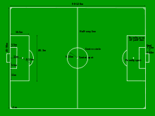](https://en.wikipedia.org/wiki/File:Football_pitch_metric.svg)

As the Laws were formulated in England, and were initially administered solely by the four British football associations within [IFAB](https://en.wikipedia.org/wiki/IFAB), the standard dimensions of a football pitch were originally expressed in [imperial units](https://en.wikipedia.org/wiki/Imperial_units). The Laws now express dimensions with approximate [metric](https://en.wikipedia.org/wiki/SI) equivalents (followed by traditional units in brackets), though use of imperial units remains popular in English-speaking countries with a relatively recent history of [metrication](https://en.wikipedia.org/wiki/Metrication) (or only partial metrication), such as Britain.[[88]](https://en.wikipedia.org/wiki/Association_football#cite_note-90)

The length of the pitch, or field, for international adult matches is in the range of 100–110 m (110–120 yd) and the width is in the range of 64–75 m (70–80 yd). Fields for non-international matches may be 90–120 m (100–130 yd) length and 45–90 m (50–100 yd) in width, provided that the pitch does not become square. In 2008, the IFAB initially approved a fixed size of 105 m (115 yd) long and 68 m (74 yd) wide as a standard pitch dimension for international matches;[[89]](https://en.wikipedia.org/wiki/Association_football#cite_note-91) however, this decision was later put on hold and was never actually implemented.[[90]](https://en.wikipedia.org/wiki/Association_football#cite_note-92)

The longer boundary lines are *touchlines*, while the shorter boundaries (on which the goals are placed) are *goal lines*. A rectangular goal is positioned at the middle of each goal line.[[91]](https://en.wikipedia.org/wiki/Association_football#cite_note-93) The inner edges of the vertical goal posts must be 7.32 m (24 ft) apart, and the lower edge of the horizontal crossbar supported by the goal posts must be 2.44 m (8 ft) above the ground. Nets are usually placed behind the goal, but are not required by the Laws.[[92]](https://en.wikipedia.org/wiki/Association_football#cite_note-94)

In front of the goal is the penalty area. This area is marked by the goal line, two lines starting on the goal line 16.5 m (18 yd) from the goalposts and extending 16.5 m (18 yd) into the pitch perpendicular to the goal line, and a line joining them. This area has a number of functions, the most prominent being to mark where the goalkeeper may handle the ball and where a penalty foul by a member of the defending team becomes punishable by a penalty kick. Other markings define the position of the ball or players at [kick-offs](https://en.wikipedia.org/wiki/Kick-off_(association_football)), goal kicks, penalty kicks and corner kicks.[[93]](https://en.wikipedia.org/wiki/Association_football#cite_note-95)

### SoccerDuration and tie-breaking methods

#### **90-minute ordinary time**

A standard adult football match consists of two halves of 45 minutes each. Each half runs continuously, meaning that the clock is not stopped when the ball is out of play. There is usually a 15-minute half-time break between halves. The end of the match is known as full-time.[[94]](https://en.wikipedia.org/wiki/Association_football#cite_note-rule7.2-96) The referee is the official timekeeper for the match, and may make an allowance for time lost through substitutions, injured players requiring attention, or other stoppages. This added time is called *additional time* in FIFA documents,[[95]](https://en.wikipedia.org/wiki/Association_football#cite_note-97)[[96]](https://en.wikipedia.org/wiki/Association_football#cite_note-98) but is most commonly referred to as *stoppage time* or *injury time*, while *lost time* can also be used as a synonym. The duration of stoppage time is at the sole discretion of the referee. Stoppage time does not fully compensate for the time in which the ball is [out of play](https://en.wikipedia.org/wiki/Ball_in_and_out_of_play), and a 90-minute game typically involves about an hour of "effective playing time".[[97]](https://en.wikipedia.org/wiki/Association_football#cite_note-99) The referee alone signals the end of the match. In matches where a fourth official is appointed, towards the end of the half the referee signals how many minutes of stoppage time they intend to add. The fourth official then informs the players and spectators by holding up a board showing this number. The signalled stoppage time may be further extended by the referee.[[94]](https://en.wikipedia.org/wiki/Association_football#cite_note-rule7.2-96) Added time was introduced because of an incident which happened in 1891 during a match between [Stoke](https://en.wikipedia.org/wiki/Stoke_City_F.C.) and [Aston Villa](https://en.wikipedia.org/wiki/Aston_Villa_F.C.). Trailing 1–0 and witsh just two minutes remaining, Stoke were awarded a penalty. Villa's goalkeeper kicked the ball out of the ground, and by the time the ball had been recovered, the 90 minutes had elapsed and the game was over. The same law also states that the duration of either half is extended until the penalty kick to be taken or retaken is completed, thus no game shall end with a penalty to be taken.

1.